**Part 2 Plots:**

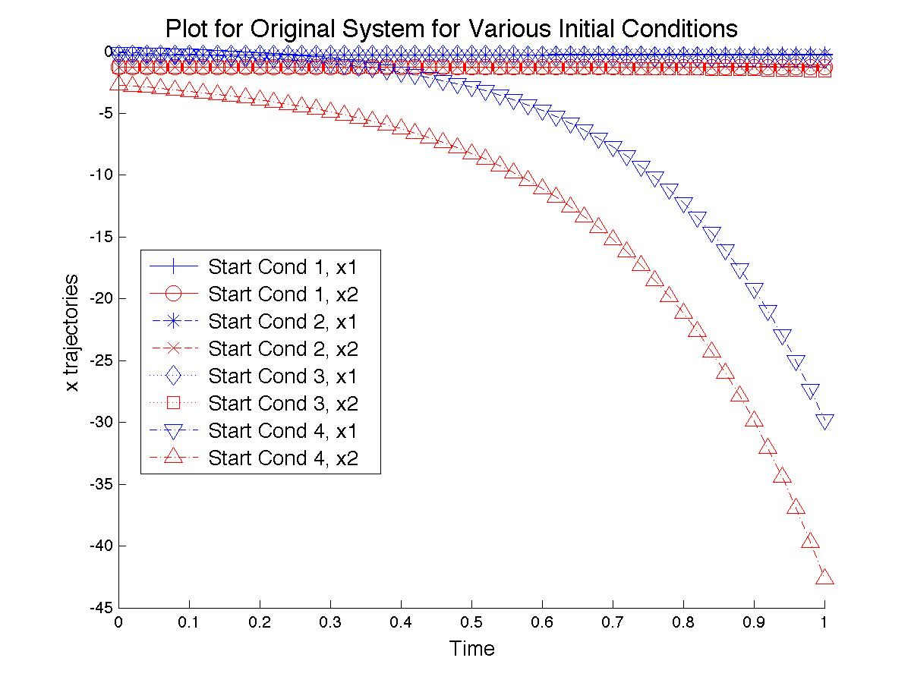

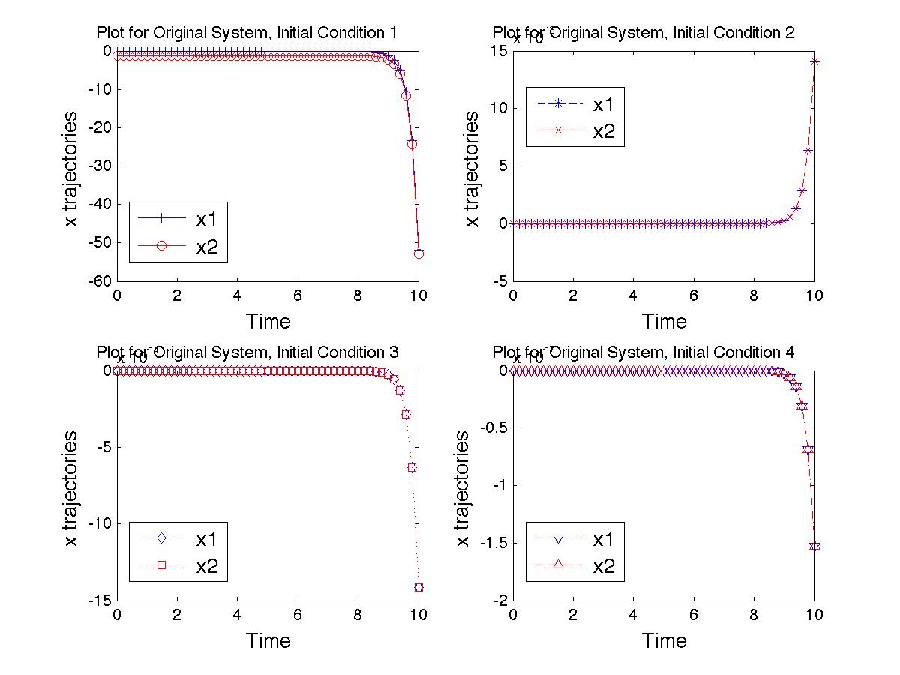

**Part 3:**

The plots for Part 2 show two different time scales and two different arrangements. The first gives the impression that the last set of initial conditions “blow up” much quicker than the other three initial conditions. Such an observation could be expected from the relative proximities of each of the initial conditions from the know equilibrium state, as the last set of condition is at least an order of magnitude further away from the equilibrium conditions than the other three. Therefore, one would expect a more rapid divergence from equilibrium. The second plot shows that all of the initial conditions eventually diverge from equilibrium (note: the scales on the “x trajectories” axis for the last three plots are 1018, 1014, and 1017, respectively). For the last three, this is expected, as the starting values differ from the equilibrium value. The first initial condition set, however, represents the equilibrium setting, so such divergence is not expected. The eventual divergence must be the result of some sort of approximated mathematical process in MATLAB and the unstable nature of the system (current eigenvalues of A are {2,4}). Note that the equilibrium starting condition results in a state that is 13 orders of magnitude smaller than the next smallest state after an interval of 10 time units. The existence of such divergence, though, indicates a need for feedback in the system in order to stabilize it. In Part 4, we observe the benefits of stabilizing the system with feedback.

**Part 4:**

After linearizing the original system and computing the feedback necessary to change the eigenvalues of the system to {-1, -2}, we again plot the time evolution of the system from the initial conditions in Part 2. From the above plot, it is seen that all initial conditions converge to equilibrium. Note that the first system is only provided with the stabilizing feedback, while the second is also driven with *ue* = 2 in addition to the stabilizing feedback, resulting in all states in the first system going to zero (which is clearly another equilibrium state with *ue* = 0), while in the second all starting conditions go to the new equilibrium state corresponding to *ue* = 2, (-1, -5). This is a different equilibrium state than that of the original system, which is to be expected since we have modified the eigenvalues of the system. This simple example shows that we can drive stable systems to various equilibriums depending on the non-feedback inputs, and generate new equilibrium states with feedback inputs.

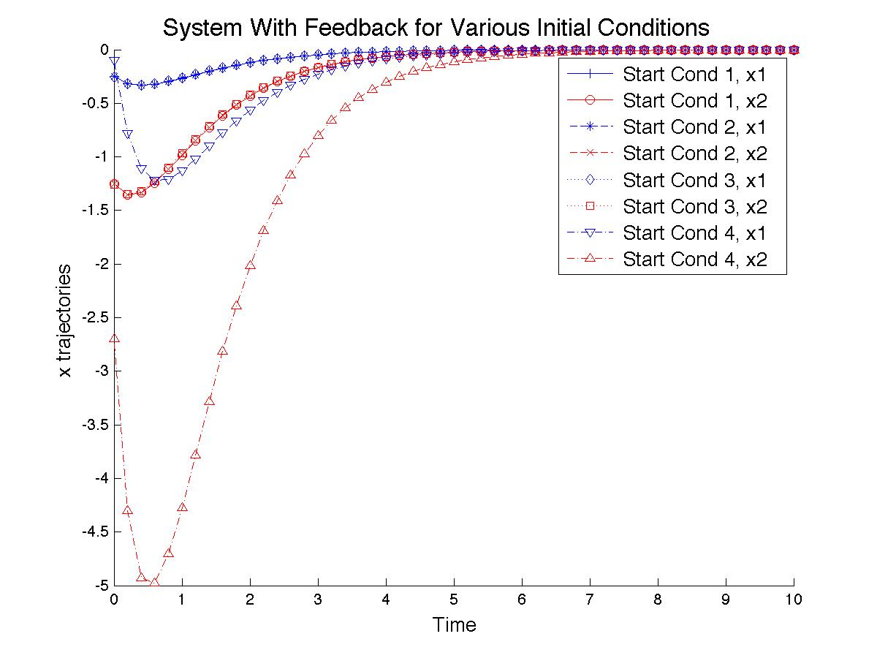

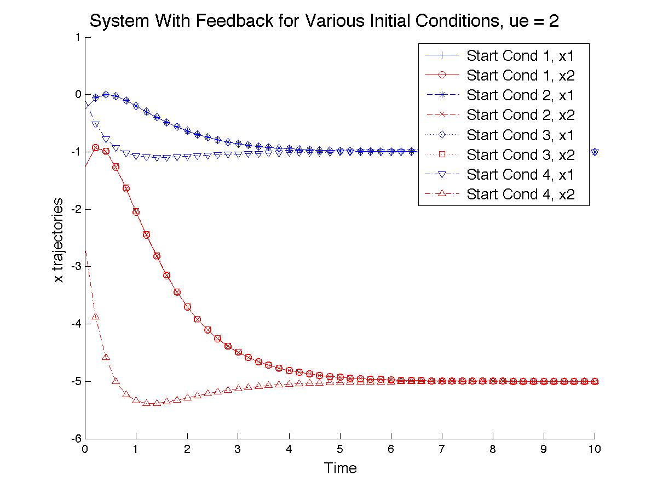**Part 7 Plots:**

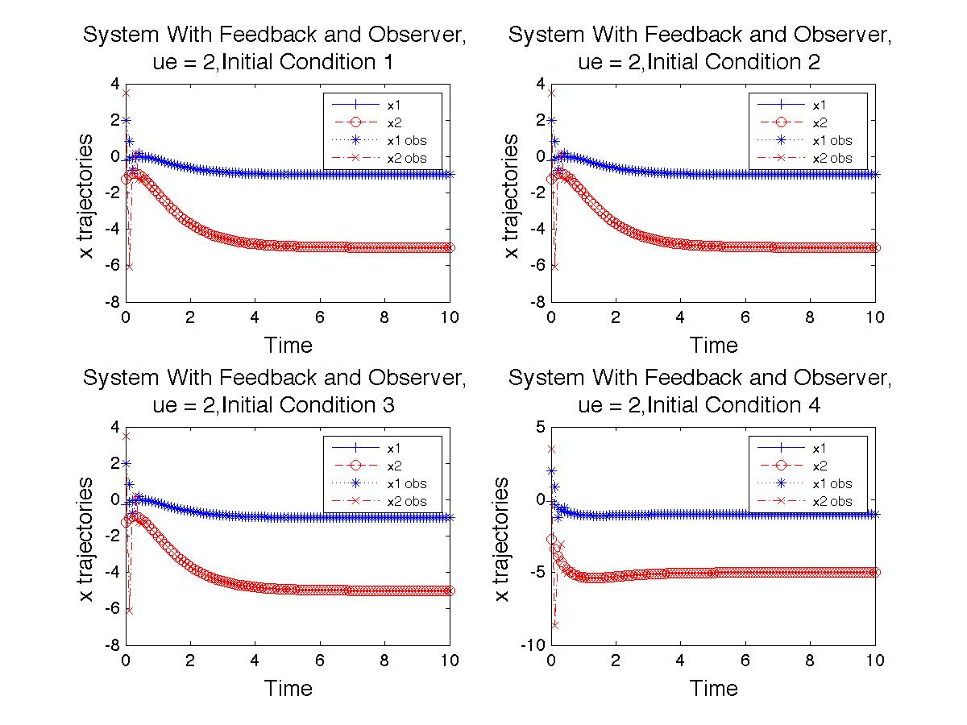

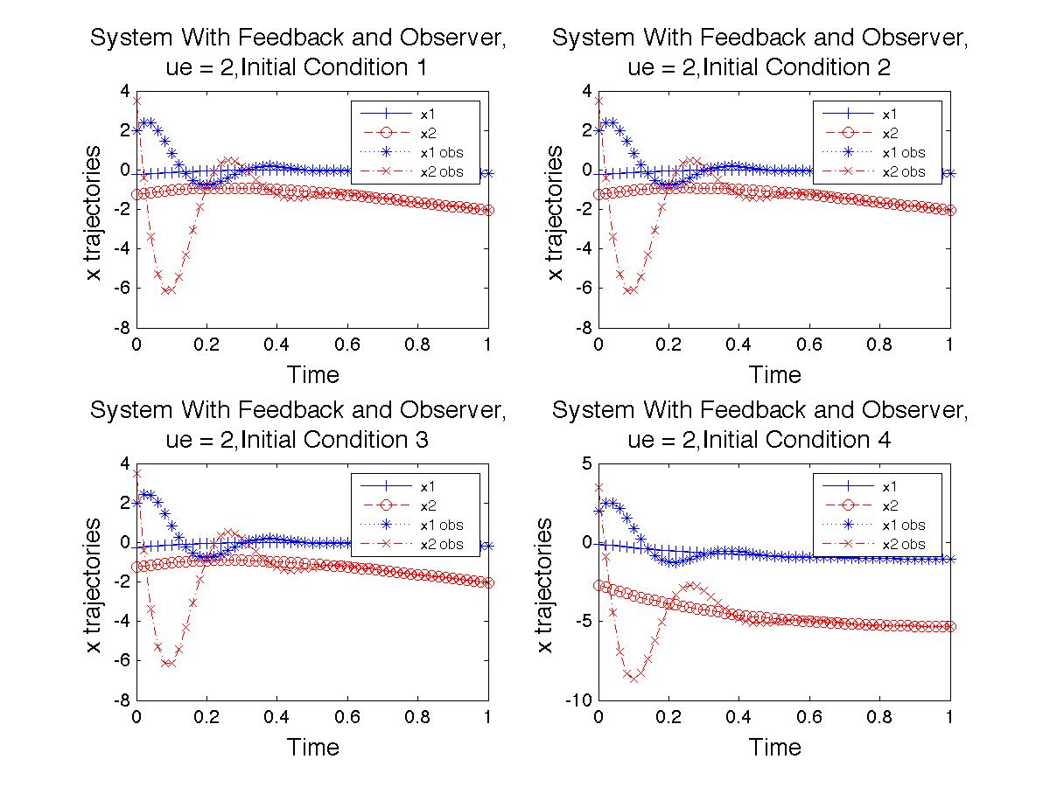

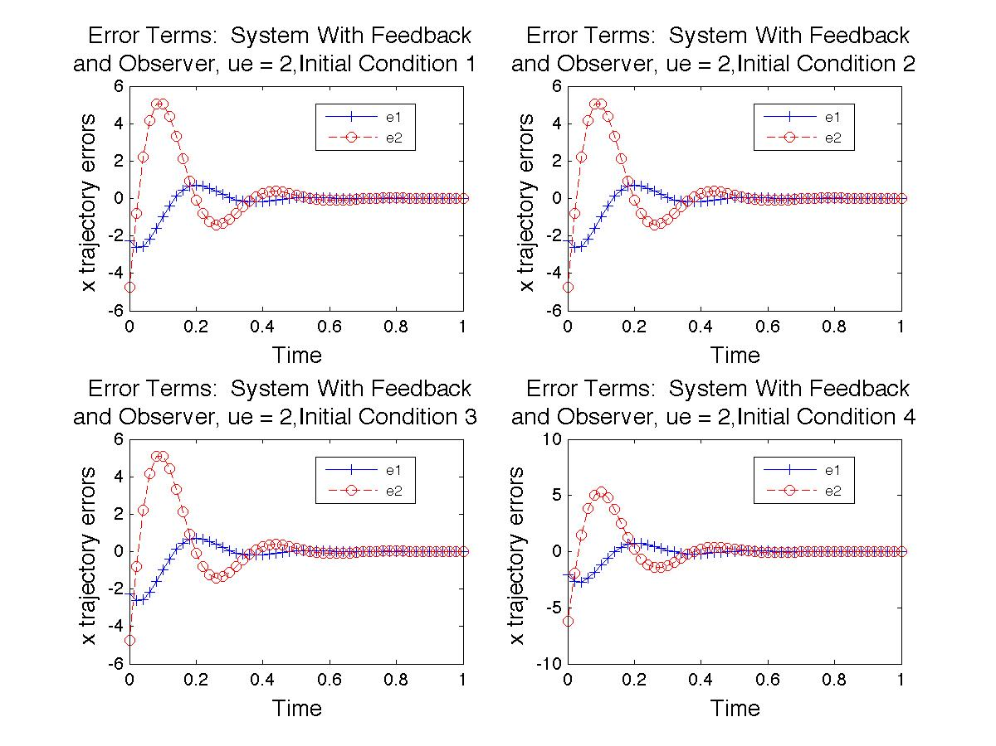

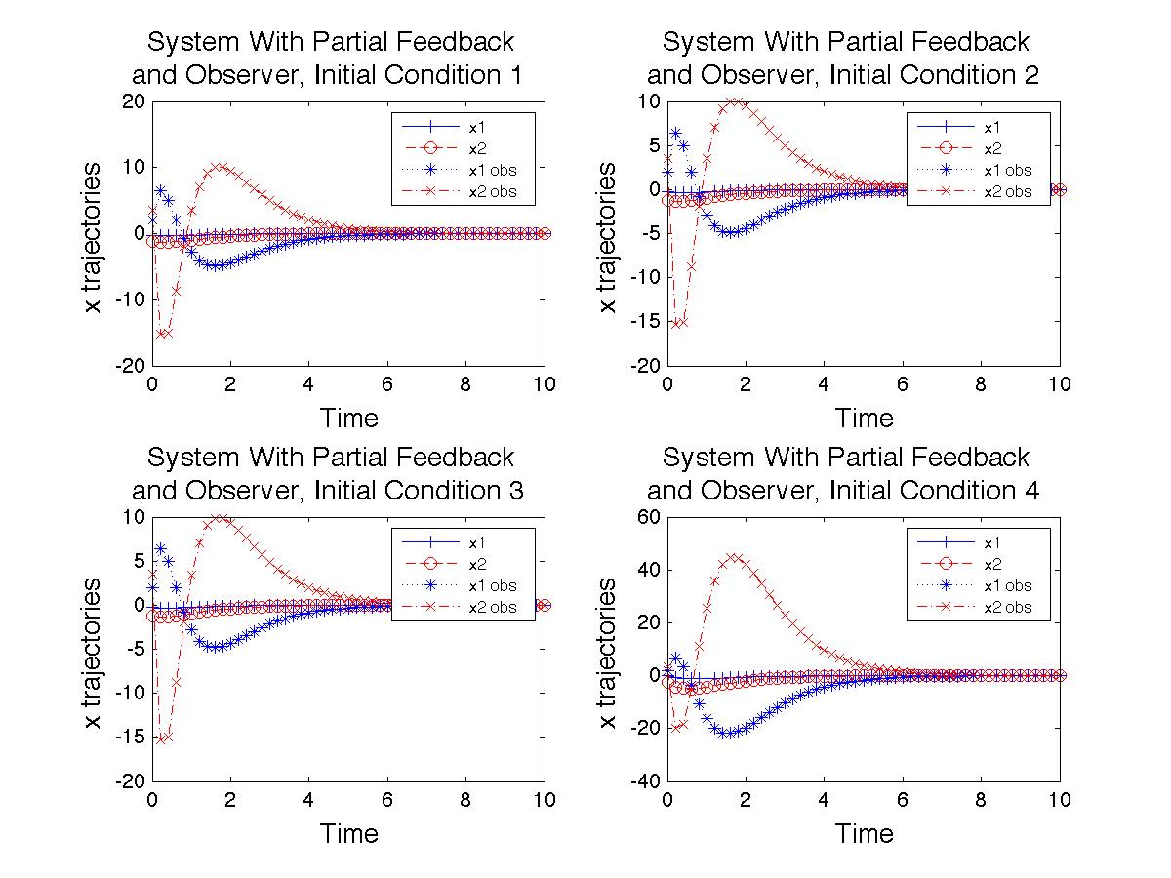

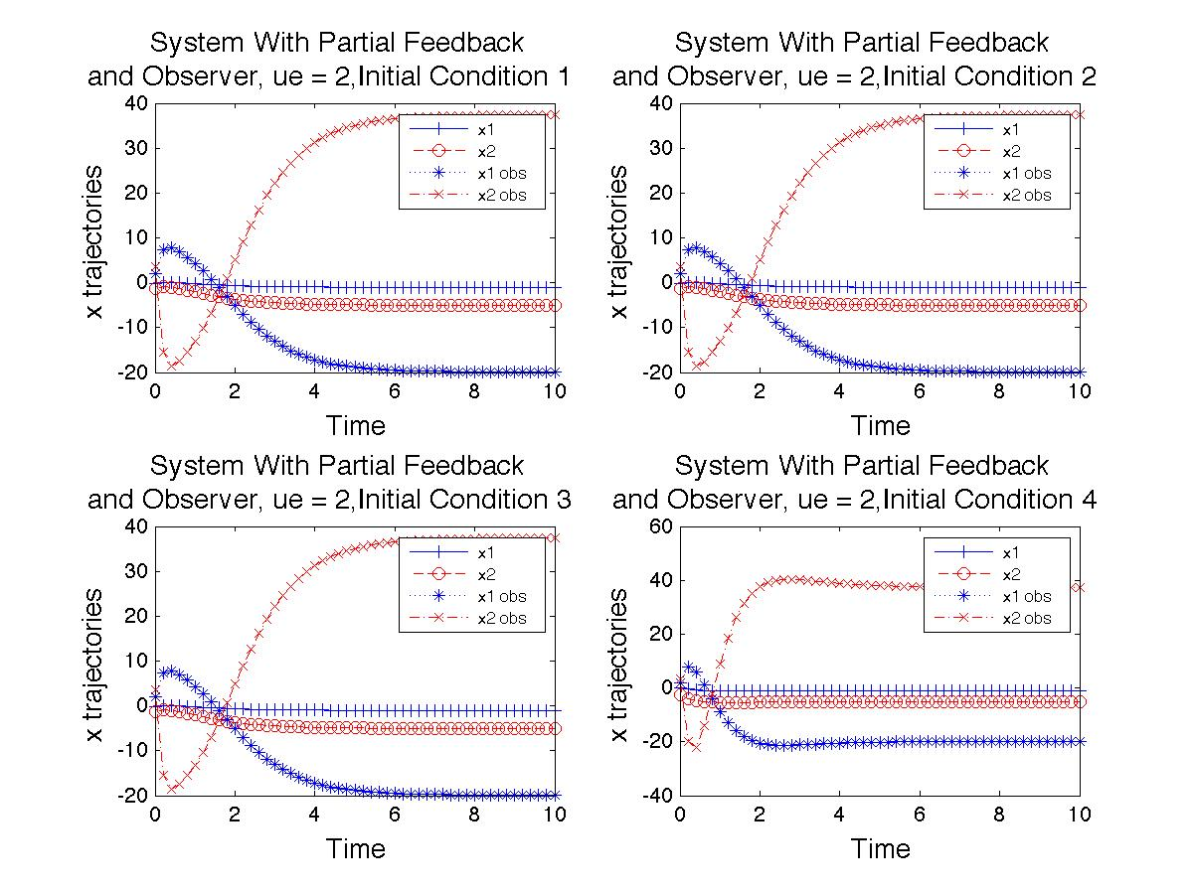

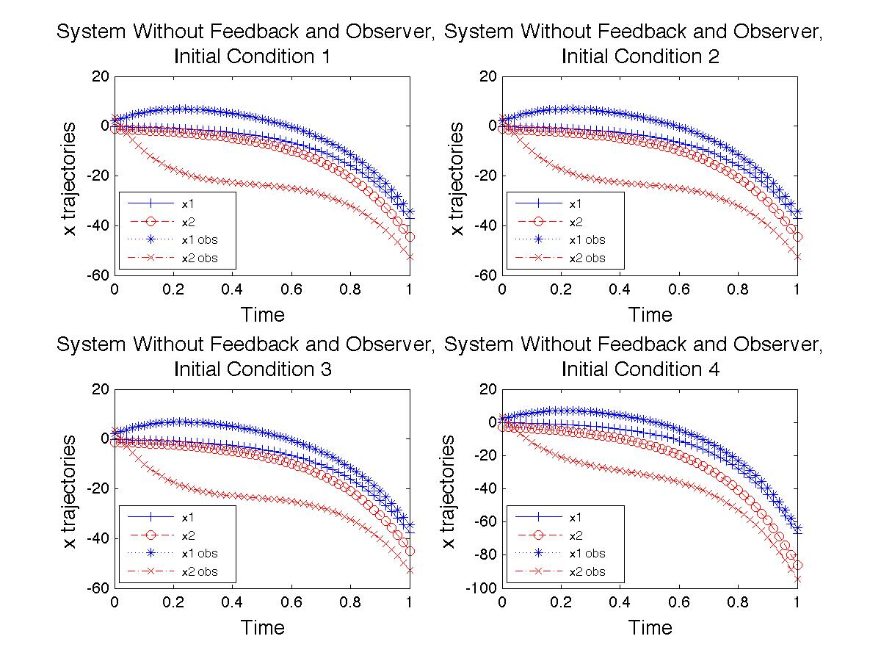

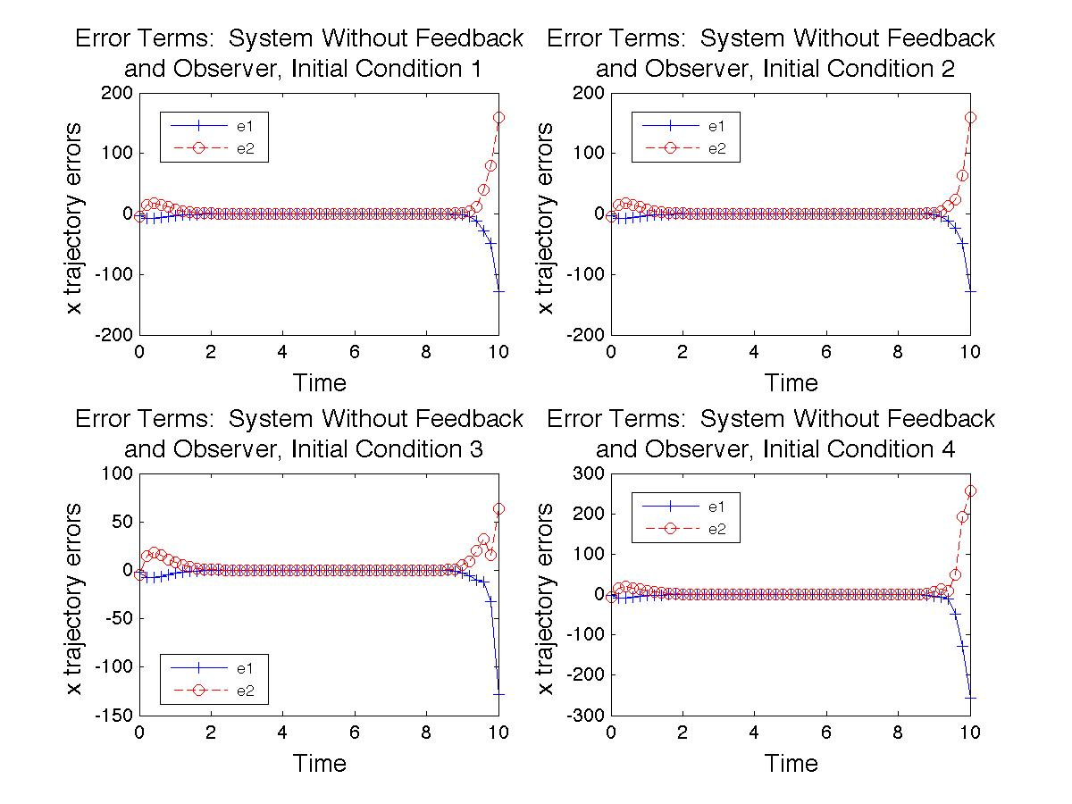

**Part 8 Plots:**

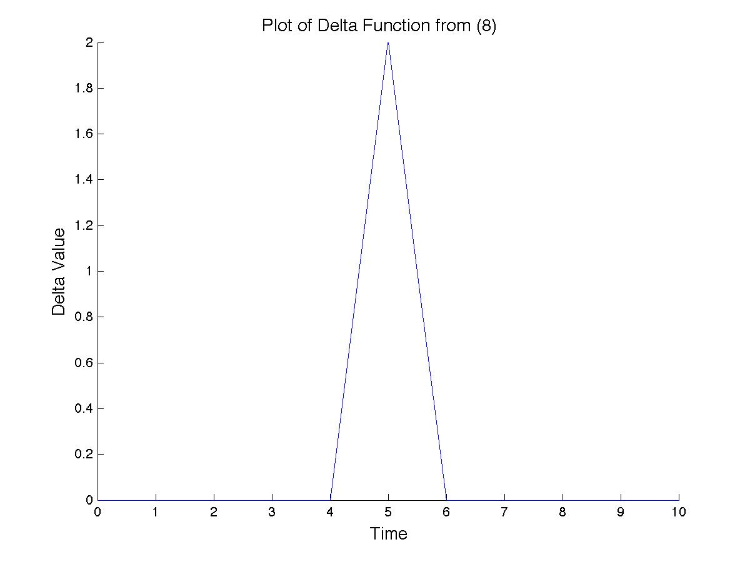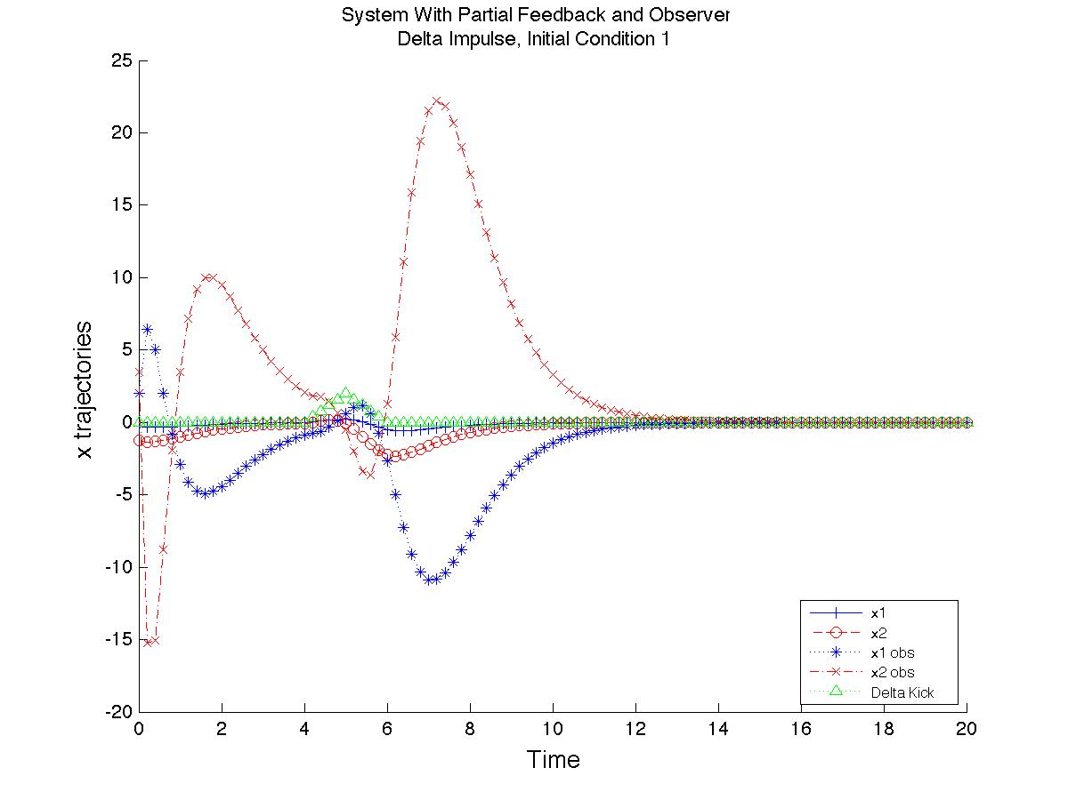

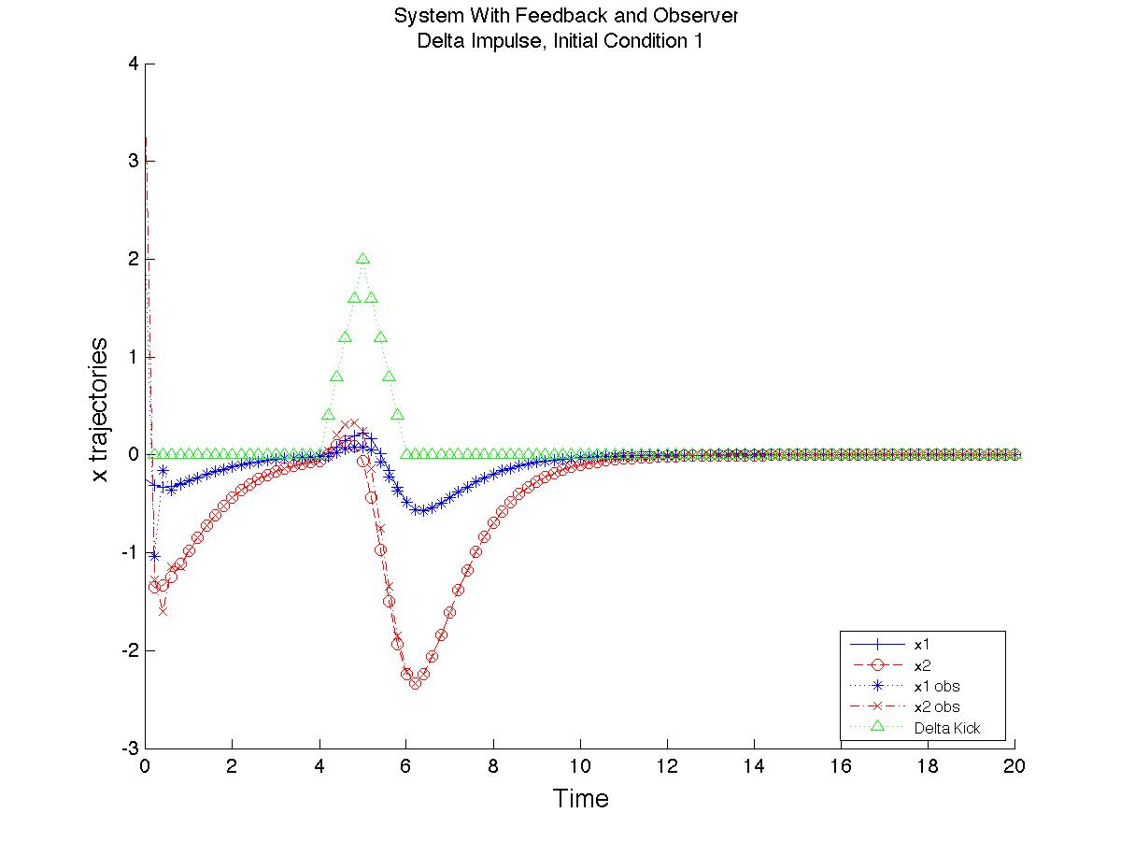

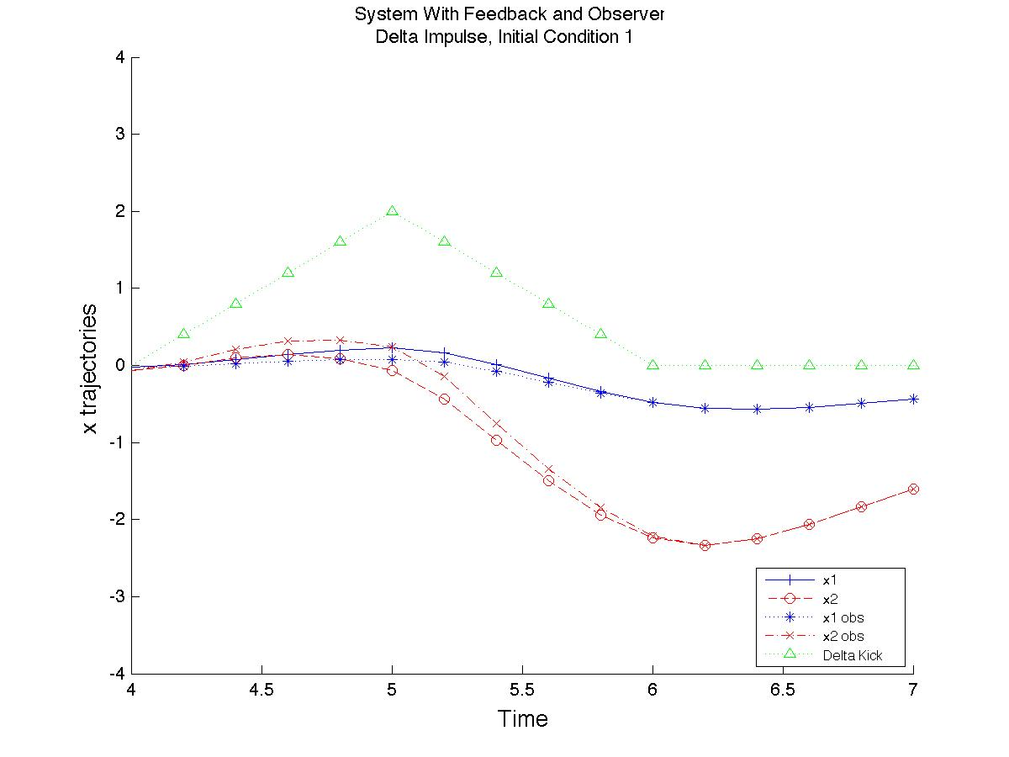

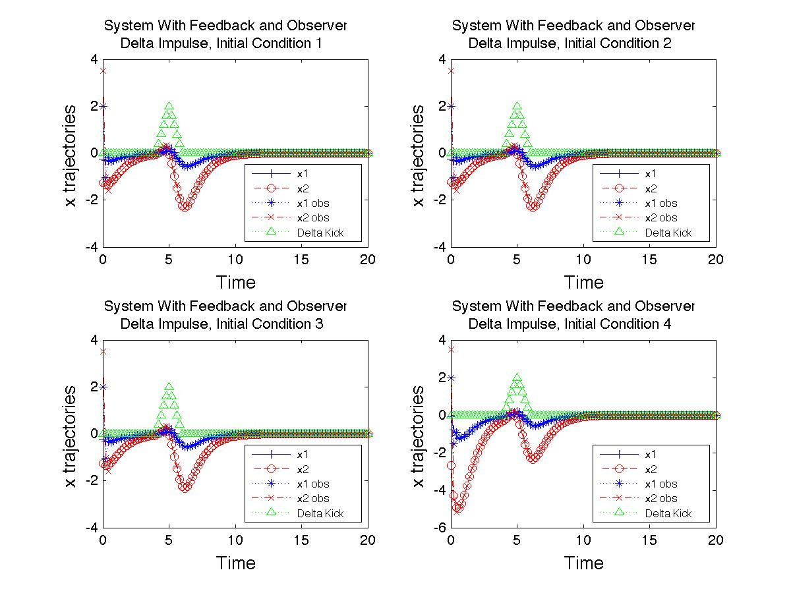

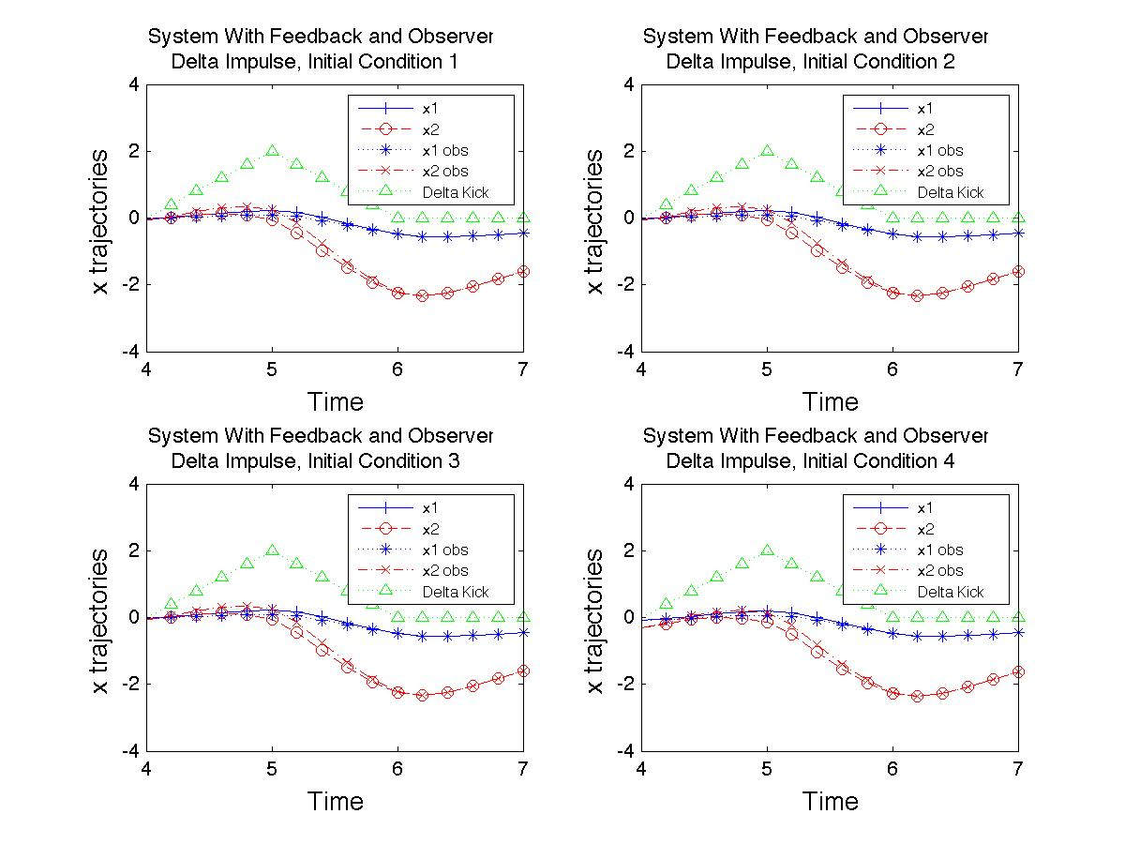

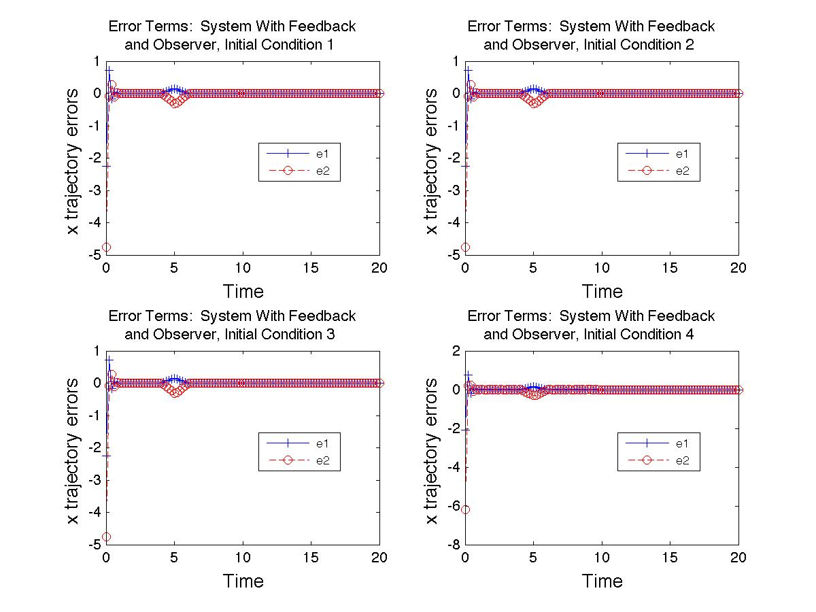

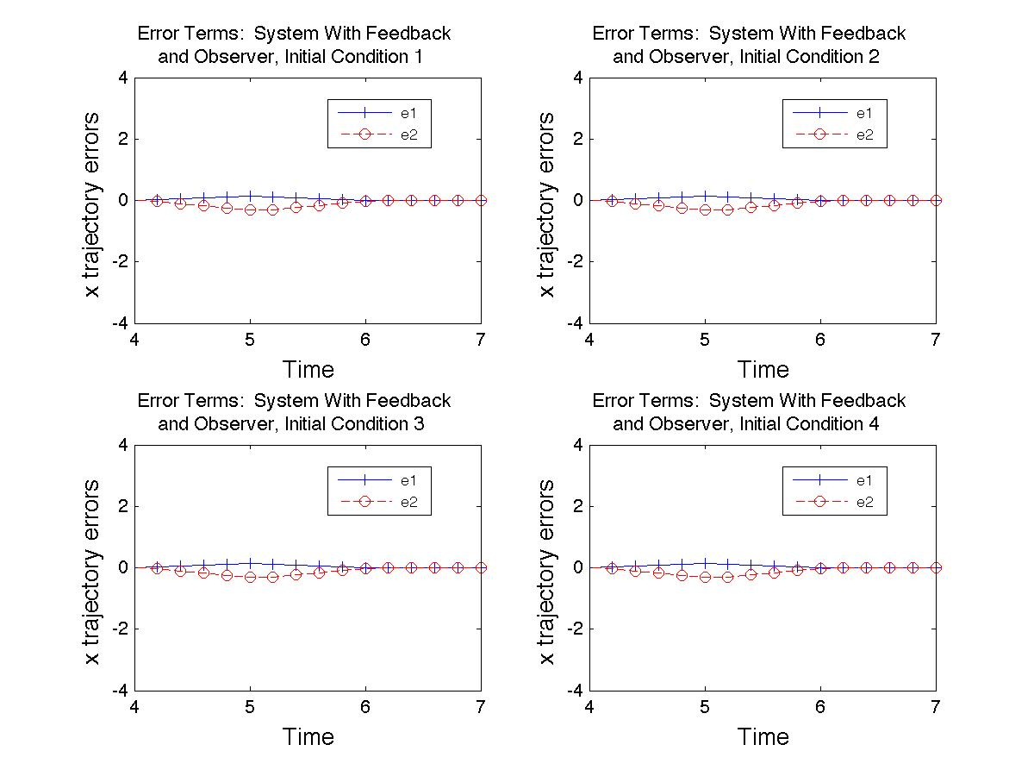

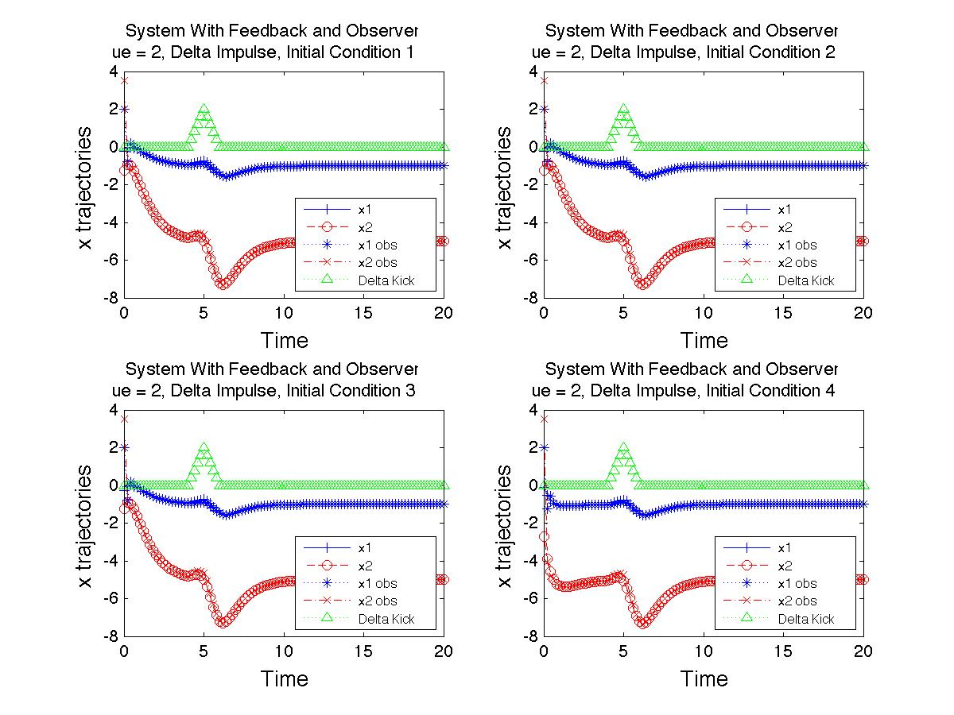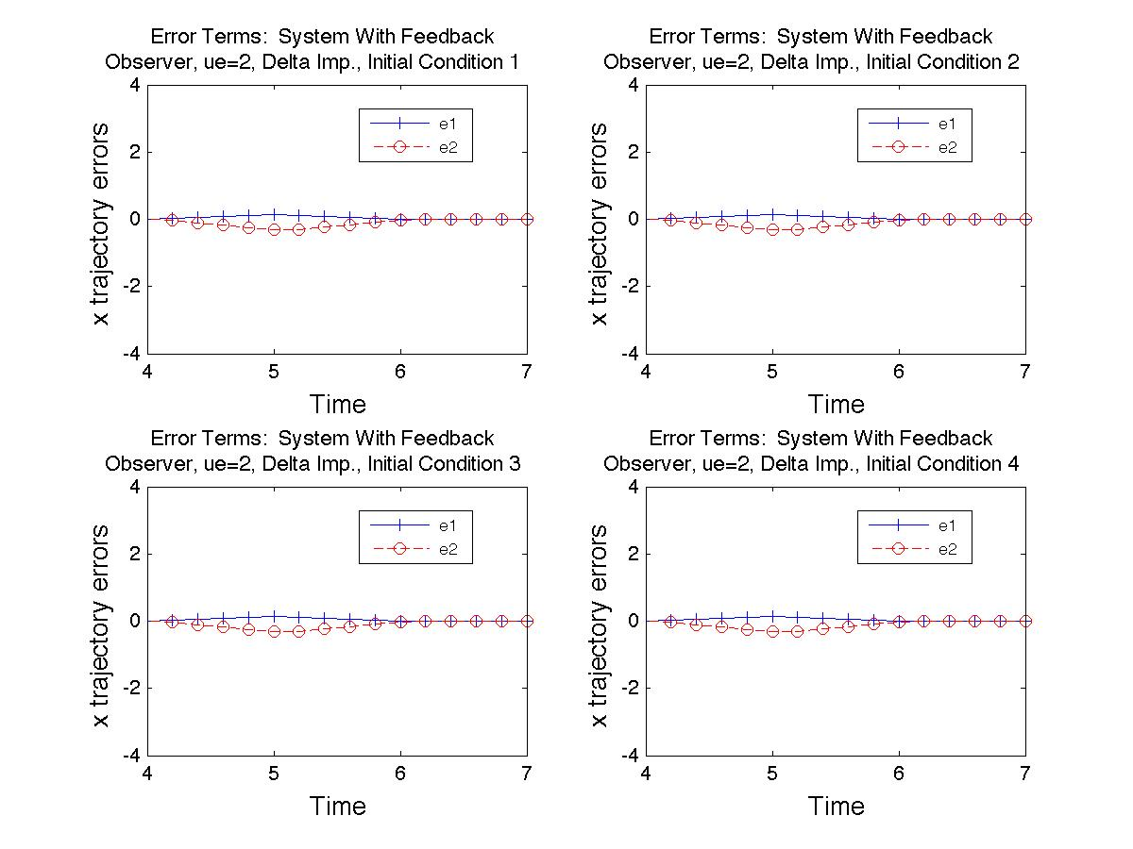

**Part 9:**

For Parts 7 and 8, the observer constructed in Part 6 is used to model the actual, original system, whose state we are only able to hypothetically observe through the output, y. In each of these parts, a distinction is made between "Full Feedback" and "Partial Feedback" the names chosen simply as an easy way to differentiate the two systems. For "Full Feedback", both the original system and the observer are stabilized as in Part 4, and the observer is additionally modified as in Part 5. For "Partial Feedback", only the latter modification is performed; that is, the primary system is stabilized as in Part 4, but not the observer. These systems are also compared to a system with "No Feedback", which indicates that both the primary and observer system are left unstable as in Part 2, and the observer is modified as in Part 5.

For Part 7, several plots are show to display the behavior of each of the above-mentioned systems. The first three sets of plots are of the "Full Feedback" system and corresponding error terms. The first shows the primary and observer system during the full 10 time unit interval. As it is difficult to observe the rather transient initial difference between the primary and observer systems, the second plot shows a smaller time interval from 0 to 1 time units. While the initial error terms are rather large compared to the magnitudes of the x trajectory values, they quickly die off (see the third plot in the series). Note that these three plots are driven with the equilibrium value, *ue = 2* in addition to the feedback.

The next two plot sets are of the "Partial Feedback" system. The first is with no additional driving force other than the feedback as in Part 4 for the primary system, and the feedback as in Part 5 for the observer. Note that this observer, too, eventually settles to the primary system values, though with much more fanfare than the "Full Feedback" system described above. In the second set of plots, both systems are driven with use = 2 in addition to their respective feedbacks. We see that even though the observer stabilizes, it does not converge to the value of the primary system, and instead settles to a different equilibrium. In hindsight, this should be expected after viewing Part 4, when we observed that injecting feedback into the system changed the location of one of the setpoints, namely the one located at *xe* = (-1/4, -5/4)T and *ue* = 2. In Part 8, we will see that these systems are quite able to track the primary system, even with disturbances.

The last two plots in the series display results from simulating the "No Feedback" system, for which only the observer has feedback to track the primary system. From part 2, we know that this system rapidly grows in magnitude, so only the span from 0 to 1 times units is shown. From this plot, it seems that the observer will eventually converge to the primary system's value. The error plot, however, shows that this is not the case. Though the two are very similar for a span of time, the observer eventually diverges from the primary system's values. Though perhaps creating a “better” feedback for the observer could extend the time frame for approximate following, such unstable systems do not seem to lend themselves to be easily tracked.

In Part 8, the primary-observer system is observed under affect of a kick to the primary system, shown in the first plot (the delta-kick function from Part 8). The second plot in the sequence shows the "Partial Feedback" primary-observer system response to the delta-kick, and the third is the "Full Feedback" primacy-observer system response to the delta-kick, both for only the first initial condition from Part 2, for clarity. While both do track the primary system, it is clear that the second does a much better job of following the primary system during and after the kick. Additionally, the "Partial" system amplifies the effects of the kick in the observer system, which could potentially be useful, though seems inefficient at the very least if one’s goal is to track the primary system. The third plot shows the time span around the delta kick region for the "Full Feedback" system. The next set of four plots show all initial conditions from Part 2 for the "Full Feedback" system in response to the delta kick. The first two display the system response for a span of 20 time units and the time span around the delta-kick, respectively. The last two are plots of the error corresponding to these plots. The last two sets of plots show the “Full Feedback” system with *ue = 2* input.

**Code:**

*Part 2:*

function HW12_CalcPlots(GraphMethod)

A1 = [3,1;1,3];

B1 = [1;2];

xe = [-1/4;-5/4];

%Part (2): Plot original form around xe, u = 2.

%Declare nec. variables

ue = 2;

t_int = 0:0.02:1;

x_start = [-.25, -.2501, -.256, -.1; -1.25, -1.2487, -1.256, -2.7];

sys1 = ss(A1,B1,[],[]);

color = {'-b+','-ro','--b*','--rx',':bd',':rs','-.bv','-.r^'};

switch GraphMethod

case 1

figure;

title('\fontsize{16} Plot for Original System for Various Initial Conditions');

xlabel('\fontsize{13} Time');

ylabel('\fontsize{13} x trajectories');

hold on;

for jj = 1:4

[~,t,x] = lsim(sys1,ue*ones(size(t_int)),t_int,x_start(:,jj));

plot(t,x(:,1), color{2*jj-1},...

t,x(:,2), color{2*jj},'MarkerSize',10);

end

legend('\fontsize{13} Start Cond 1, x1',...

'\fontsize{13} Start Cond 1, x2',...

'\fontsize{13} Start Cond 2, x1',...

'\fontsize{13} Start Cond 2, x2',...

'\fontsize{13} Start Cond 3, x1',...

'\fontsize{13} Start Cond 3, x2',...

'\fontsize{13} Start Cond 4, x1',...

'\fontsize{13} Start Cond 4, x2',...

'Location','Best');

hold off;

case 2

figure;

hold on;

for jj = 1:4

[~,t,x] = lsim(sys1,ue*ones(size(t_int)),t_int,x_start(:,jj));

hold on

subplot(2,2,jj);

plot(t,x(:,1), color{2*jj-1},...

t,x(:,2), color{2*jj});

title(['\fontsize{11} Plot for Original System, Initial Condition ' num2str(jj) ' ']);

xlabel('\fontsize{13} Time');

ylabel('\fontsize{13} x trajectories');

legend('\fontsize{13} x1',...

'\fontsize{13} x2',...

'Location','Best');

end

hold off;

end

*Part 4:*

function HW12p4_CalcPlots(GraphMethod)

A = [3,1;1,3];

B = [1;2];

Fc = [6,-9];

CC = [B,A*B];

CCinv = CC^-1;

q = CCinv(end,:);

P = [q;q*A];

F = Fc*P;

ue = 0;

%Part (4): Plot original system with control feedback

t_int = 0:0.2:10;

x_start = [-.25, -.2501, -.256, -.1; -1.25, -1.2487, -1.256, -2.7];

sys1 = ss(A+B*F,B,[],[]);

color = {'-b+','-ro','--b*','--rx',':bd',':rs','-.bv','-.r^'};

switch GraphMethod

case 1

figure;

title('\fontsize{16} System With Feedback for Various Initial Conditions');

xlabel('\fontsize{13} Time');

ylabel('\fontsize{13} x trajectories');

hold on;

for jj = 1:4

[~,t,x] = lsim(sys1,ue*ones(size(t_int)),t_int,x_start(:,jj));

plot(t,x(:,1), color{2*jj-1},...

t,x(:,2), color{2*jj});

end

legend('\fontsize{13} Start Cond 1, x1',...

'\fontsize{13} Start Cond 1, x2',...

'\fontsize{13} Start Cond 2, x1',...

'\fontsize{13} Start Cond 2, x2',...

'\fontsize{13} Start Cond 3, x1',...

'\fontsize{13} Start Cond 3, x2',...

'\fontsize{13} Start Cond 4, x1',...

'\fontsize{13} Start Cond 4, x2',...

'Location','NE');

hold off;

case 2

figure;

hold on;

for jj = 1:4

[~,t,x] = lsim(sys1,ue*ones(size(t_int)),t_int,x_start(:,jj));

subplot(2,2,jj);

plot(t,x(:,1), color{2*jj-1},...

t,x(:,2), color{2*jj});

title(['\fontsize{13} System With Feedback, Initial Condition ' num2str(jj) ' ']);

xlabel('\fontsize{13} Time');

ylabel('\fontsize{13} x trajectories');

legend('\fontsize{13} x1',...

'\fontsize{13} x2',...

'Location','NE');

end

hold off;

end

*Part 5:*

function out = HW12p5_Calcs(CharPoly)

A1 = [3,1;1,3];

C1 = [2,1];

OO = [C1;C1*A1];

%Calculate value for K in "e(t) = exp[(A-KC)t]e(0)"

Ko = CharPoly(A1)/OO*[0;1];

out = [Ko A1-Ko*C1];

*Part 6/7:*

Code for parts 6/7 and 8 are the same except for the input of the Delta Kick in part 8, so I have left code for Part 6 out for brevity.

*Part 8:*

function HW12p8_CalcPlots()

%Declare basic problem variables

A = [3,1;1,3];

B = [1;2];

C = [2,1];

Fc = [6,-9];

CC = [B,A*B];

CCinv = CC^-1;

q = CCinv(end,:);

P = [q;q*A];

F = Fc*P;

ue=0;

%Get K from part 5

CharPoly1 = inline('A*A+6*A+9*eye(length(A))');

% CharPoly2 = inline('A*A-20*A+100*eye(length(A))');

temp = HW12p5_Calcs(CharPoly1);

K = temp(:,1);

%Declare Problem Specific Variables

Ap1 = [A+B*F,0*ones(size(A));...

K*C,A-K*C+B*F];

Bp = [B,B;B,0*ones(size(B))];

Cp = [C,0*ones(size(C));...

0*ones(size(C)),C];

%Define variables for calc'ing trajectories, plotting

t_int = 0:0.2:20;

ErrorTerms = zeros(length(t_int),8);

x_start = [-.25, -.2501, -.256, -.1; -1.25, -1.2487, -1.256, -2.7];

x_obs_start = [2;3.5];

color = {'-b+','--ro',':b*','-.rx',':g^',':rs','-.bv','-.r^'};

sys1 = ss(Ap1,Bp,Cp,[]);

%Plot

figure;

hold on;

for jj = 1:4

[~,t,x] = lsim(sys1,[ue*ones(size(t_int))',DeltaPlot(t_int,0)'],...

t_int,[x_start(:,jj)',x_obs_start']');

ErrorTerms(:, 2*jj-1:2*jj) = x(:,1:2)-x(:,3:4);

subplot(2,2,jj);

plot(t,x(:,1), color{1},...

t,x(:,2), color{2},...

.

t,x(:,3), color{3},...

t,x(:,4), color{4},...

t,DeltaPlot(t_int,0), color{5});

axis([4 7 -4 4])

title({('\fontsize{11} System With Feedback and Observer,');...

['\fontsize{11} Delta Impulse, Initial Condition ' num2str(jj) ' ']});

xlabel('\fontsize{13} Time');

ylabel('\fontsize{13} x trajectories');

legend('\fontsize{8} x1',...

'\fontsize{8} x2',...

'\fontsize{8} x1 obs',...

'\fontsize{8} x2 obs',...

'\fontsize{8} Delta Kick',...

'Location','NE');

end

hold off;

%Plot error terms for x1, x2

figure;

hold on;

for jj = 1:4

subplot(2,2,jj);

plot(t,ErrorTerms(:,2*jj-1), color{1},...

t,ErrorTerms(:,2*jj), color{2});

axis([4 7 -4 4])

title({('\fontsize{11} Error Terms: System With Feedback ');...

['\fontsize{11} Observer, ue=2, Delta Imp., Initial Condition ' num2str(jj) ' ']});

xlabel('\fontsize{13} Time');

ylabel('\fontsize{13} x trajectory errors');

legend('\fontsize{8} e1',...

'\fontsize{8} e2',...

'Location','Best');

end

hold off;